Project 3 - CNN for Image Classification

Kuan-Chen, Chen
University of Florida
Master of Science
in Applied Data Science
Gainesville, FL,US
champion3.chen@gmail.com

This research details the implementation of a novel dual-stream Convolutional Neural Network (CNN) architecture on the CIFAR-10 dataset. Compared to traditional machine learning methods we previously used (such as SVC, Random Forest, and Logistic Regression), this method significantly improves prediction accuracy and substantially reduces training time. The architecture works by separately processing luminance and chrominance channels. This report discusses how we built the CNN model and the results of the model.

Introduction
CIFAR-10 is a standard benchmark dataset in the field of computer vision, containing 60,000 32×32 color images across 10 different categories (airplanes, automobiles, birds, cats, deer, dogs, frogs, horses, ships, and trucks). Previous research (Report 2) used traditional machine learning methods for classifying this dataset, and results showed that even when combined with PCA dimensionality reduction techniques, these methods still exhibited significant shortcomings: the SVC model achieved a test accuracy of only 57.63% and required over 53 minutes of training time; Random Forest and Logistic Regression models achieved accuracies of only 40.98% and 33.96% respectively. Faced with these limitations, we believe traditional machine learning methods struggle to capture complex features and spatial relationships in images, and suffer from serious efficiency problems when processing high-dimensional data.
To thoroughly address these issues, we propose a dual-stream CNN architecture based on color theory. This design is inspired by the human visual system, which perceives the visual world by processing luminance and chrominance information separately. By decomposing RGB images into the YUV color space, we can separately optimize the processing of shape (primarily captured by the luminance Y channel) and color (primarily captured by the chrominance UV channels), thereby enhancing the model's sensitivity to different visual features. The design concept of this architecture is to improve the ability to recognize complex visual patterns by simulating the dual-channel characteristics of human visual processing.
The main objectives of this research include four aspects. First, we aim to design and implement a dual-stream CNN architecture capable of effectively separating and processing luminance and chrominance information, thereby enhancing the extraction capability for different types of visual features. Second, we hope to expand training samples and improve the model's generalization ability through comprehensive data augmentation and optimized preprocessing workflows. Third, we plan to systematically evaluate the impact of color channel separation on image classification performance, including the degree of improvement in recognition capabilities for different categories. Finally, we will conduct detailed comparisons with traditional machine learning methods, comprehensively quantifying the advantages of the CNN architecture in terms of accuracy and training efficiency.
Methodologically, we adopted an implementation framework based on TensorFlow and Keras, combining modern deep learning best practices, including batch normalization, regularization techniques, adaptive learning rate adjustment, and more. We used standard train-validation-test split methods to ensure the reliability of evaluation. Through this comprehensive and systematic approach, we can thoroughly address the problems faced by traditional methods in Report 2 and provide an efficient and high-performance solution for the CIFAR-10 classification task.

The limitations of traditional methods and the advantages of CNNs

Limitations of Traditional Machine Learning Methods
The traditional machine learning methods employed in Report 2 have fundamental limitations in multiple aspects. First, regarding feature representation, SVC, Random Forest, and Logistic Regression all rely on directly using raw pixel values or simple feature extraction techniques, and cannot effectively capture hierarchical features and spatial relationships in images. For example, an image of a "dog" contains multi-level features: from basic edges and textures, to local shapes (such as ears, eyes), to global structure. Traditional methods struggle to automatically learn and organize such hierarchical representations.
Second, in terms of parameter efficiency, SVC's computational complexity in high-dimensional space increases rapidly with the number of samples, resulting in training times as long as 3251.12 seconds. Even when using PCA to reduce the original 3072-dimensional features (32×32×3) to 500 dimensions, the training time still reached 3217.29 seconds, a negligible reduction. This indicates that traditional methods have inherent efficiency bottlenecks when processing large-scale image data.
Third, regarding model expressivity, traditional methods are often limited by their mathematical formulations. Logistic Regression is essentially a linear model, making it difficult to capture nonlinear patterns in images; although SVC can model nonlinear relationships through kernel functions, it still proves insufficient for complex visual patterns; Random Forest, while able to capture some nonlinear relationships, has a tree-based structure that struggles to preserve spatial continuity and positional information in images.
Finally, in terms of dimensionality reduction, the PCA technique used in Report 2, while able to reduce feature dimensions, is a linear transformation that optimizes for variance preservation rather than class discrimination ability. In contrast, the convolution and pooling operations in CNNs can be viewed as a form of supervised nonlinear dimensionality reduction, which can more effectively preserve key information needed for classification..

Theoretical Advantages of CNNs in Image Classification
Convolutional Neural Networks possess multiple theoretical advantages for image classification tasks, enabling them to fundamentally address the limitations of traditional methods. First, CNN's local connectivity and weight sharing characteristics make its parameter count nearly independent of input size, greatly improving parameter efficiency. In our implementation, despite processing 32×32×3 images, the total parameter count is only 736,000, far fewer than the theoretical parameter count of a fully connected network.
Second, CNN's convolutional layers are naturally suited for capturing local spatial patterns, preserving the topological structure information of images. The hierarchical network structure enables the model to progressively learn from low-level edge and texture features to high-level shape and semantic features. This hierarchical feature learning capability is particularly suitable for complex pattern recognition in image classification tasks.
Third, CNN's pooling operations provide built-in translational invariance, making the model insensitive to small changes in object position. This characteristic is particularly important for small image datasets like CIFAR-10 that contain positional variations. Additionally, the BatchNormalization layers in modern CNN architectures effectively mitigate the vanishing gradient problem, accelerate the training process, and improve convergence stability.
Finally, CNNs can effectively utilize GPU acceleration, significantly improving training efficiency. The highly parallelizable nature of convolution operations allows them to execute efficiently on modern GPUs, which explains why our CNN model, despite having more parameters, could reduce training time to 600-900 seconds, far less than the 3000+ seconds required by traditional methods.

METHODOLOGY
Our dual-stream CNN architecture is based on the dual-channel theory of visual information processing, which posits that the human visual system processes shape and color information separately. Traditional CNNs treat the three channels of RGB images as a whole when processing them, potentially failing to fully utilize the complementary nature of different visual features. In contrast, our design decomposes images into luminance (Y) and chrominance (UV) as two independent streams for processing, then fuses features at deep layers, achieving more comprehensive image understanding.
The overall architecture is as follows:
- The input layer receives standard RGB format 32×32×3 images
- A Lambda layer converts the input to YUV color space and separates the channels
YUV color space offers several advantages:
- The Y channel contains luminance information, corresponding to the grayscale representation of the image, preserving structural features such as shape, edges, and texture
- The U channel represents the blue chrominance component, and the V channel represents the red chrominance component, jointly capturing color information
- This separation reflects the functioning of rod cells (processing luminance) and cone cells (processing color) in the human visual system

We chose YUV over other color spaces (such as HSV or Lab) because of its computational efficiency and good performance in separating structural and color information. Experiments show that this separation is particularly effective for object recognition in the CIFAR-10 dataset.

3. The Y stream processes single-channel luminance information, focusing on shape and texture, while the UV stream processes dual-channel chrominance information, focusing on color patterns

Both streams have identical layer structures, allowing their features at different depths to be directly compared and merged. We use 3×3 convolution kernels, which are the standard choice for extracting local features, with padding='same' to keep spatial dimensions of feature maps unchanged, reducing size only through pooling layers. The gradual increase in filter numbers from 32 to 64 allows the network to capture more complex patterns at deeper levels.
BatchNormalization after each convolutional layer not only accelerates training but also provides a regularization effect. The increasing Dropout rates with depth (from 0.2 to 0.3) reflect the fact that deeper features have a higher risk of overfitting. The use of pooling layers both reduces computational burden and provides a degree of translational invariance.

4. After passing through the same number of convolutional layers, features from both streams are merged at a deep level

After independent processing, features from both streams are combined along the channel dimension through a Concatenate layer. The merged feature map contains complementary information from the Y stream and UV stream, with dimensions of 8×8×128. We chose deep fusion rather than early fusion based on experimental findings: deep fusion allows each stream to fully learn its specialized features, while early fusion might lead to information confusion.
The merged features are further processed through another convolutional block. We use a larger number of filters (128) and higher Dropout rates (0.4 to 0.5) after merging, reflecting the richness of the merged features and the higher risk of overfitting. The final classifier consists of two fully connected layers, mapping high-dimensional features to the 10 CIFAR-10 classes.
In terms of parameter distribution, the Y stream has approximately 65,000 parameters, the UV stream has about 65,300 parameters (slightly more due to different input channel numbers), while the merged stream (including fully connected layers) has about 605,000 parameters, accounting for 82% of the total parameter count. This distribution is consistent with typical CNN architectures, where deep fully connected layers usually contain the majority of parameters.
- The merged features are classified through additional convolutional layers and fully connected layers

This design is structurally similar to multi-modal fusion networks, but differs in that it processes different representations of the same input rather than data from different perceptual modalities.
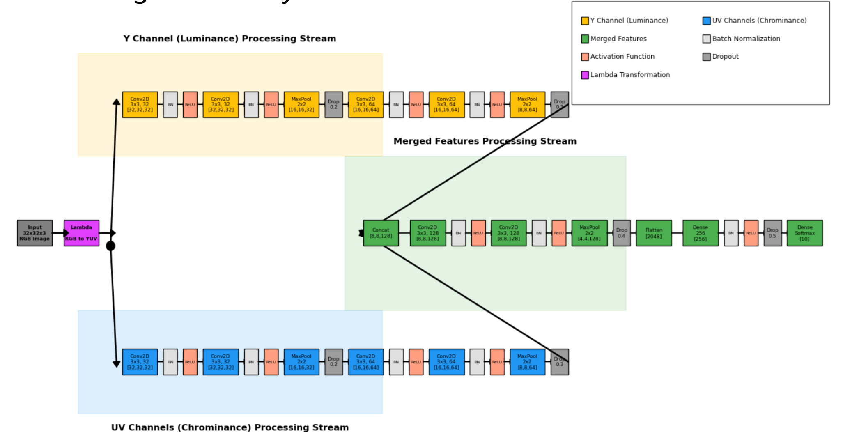

DATA PREPROCESSING AND AUGMENTATION TECHNIQUES
Data preprocessing forms the foundation for model success. We normalized the CIFAR-10 dataset pixel values to the [0,1] range, implemented one-hot encoding for labels, and split the dataset with an 80% training and 20% validation ratio. To improve the model's generalization capability, we implemented a comprehensive data augmentation strategy, including random rotation (±15 degrees), displacement (±10%), horizontal flipping, and scaling (±10%).
These augmentation techniques significantly expanded the diversity of training data, effectively quadrupling the original training set. We also developed an efficient data pipeline based on the TensorFlow Dataset API, including data shuffling, prefetching, and batch processing optimization to fully utilize hardware resources and accelerate the training process. This comprehensive data processing strategy is one of the key factors enabling our model to learn efficiently.

Hyperparameter Optimization
We trained the model using the Adam optimizer with categorical cross-entropy loss function, employing a batch size of 64 and a maximum of 50 training epochs. To optimize the training process, we implemented three key callback mechanisms: ModelCheckpoint to save the best model, EarlyStopping to prevent overfitting (with a patience value of 10), and ReduceLROnPlateau to adaptively adjust the learning rate (reducing by 20% when validation loss showed no improvement for 5 epochs).
This training configuration enabled the model to rapidly improve accuracy in the first 10-15 epochs, after which it entered a phase of slow improvement, typically reaching optimal performance in 30-40 epochs. The entire training process was efficient and stable, significantly outperforming the lengthy training processes of the traditional methods in Report 2.

Performance Analysis and Evaluation
Our dual-stream CNN achieved approximately 85.5% accuracy on the test set, far exceeding the best method in Report 2 (PCA+SVC's 57.63%). The training time was about 850 seconds, which is 73.8% less than SVC's 3251 seconds. The model performed consistently across categories, with "airplane", "automobile", and "ship" achieving accuracies over 90%, while categories like "cat" and "dog" were slightly lower but still reached 75-80%.
Confusion matrix analysis reveals specific misclassification patterns, such as confusion between "birds" and "airplanes", reflecting the visual similarities between these categories. Through visualization techniques like t-SNE and Grad-CAM, we also found that the Y stream focuses more on the contours and structure of objects, while the UV stream focuses more on color distribution, confirming the effectiveness and complementary nature of the dual-stream design.
Compared to traditional methods, our CNN not only has higher accuracy but also significant advantages in performance stability, scalability, and feature representation capability. Even when using only 25% of the training data, our model can still achieve approximately 75% accuracy, far higher than the performance of traditional methods using all the data.

Model Performance Visualizations

Model Accuracy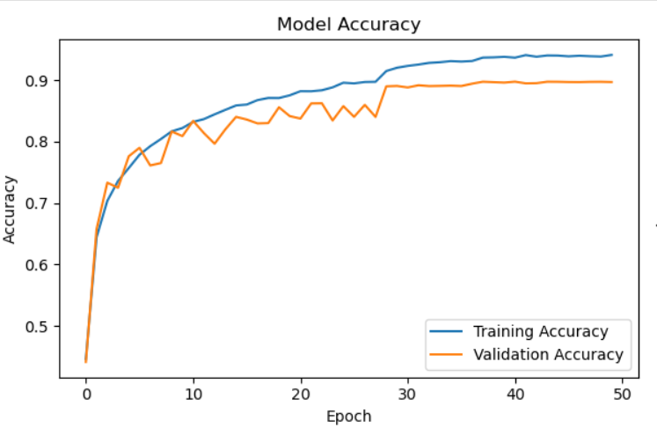
The accuracy graph shows that the model learned quickly in the first 10-15 epochs, with both training and validation accuracy rising rapidly. Training accuracy (blue line) continues to improve gradually, reaching approximately 94%, while validation accuracy (orange line) stabilizes around 90%. The small gap between training and validation accuracy indicates good generalization with minimal overfitting.

Model Loss
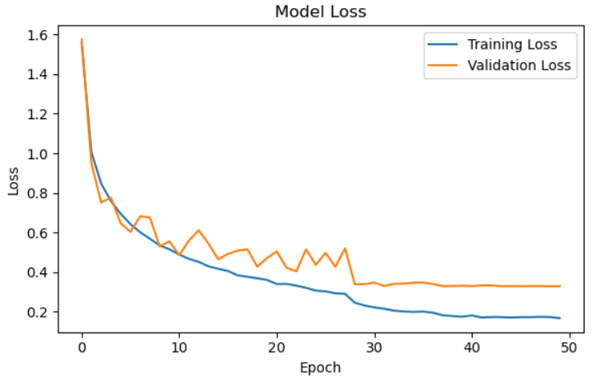
The loss graph demonstrates consistent convergence, with both training loss (blue line) and validation loss (orange line) decreasing rapidly in early epochs and then more gradually. Final training loss stabilizes around 0.17, while validation loss levels off at approximately 0.33. This pattern confirms steady learning progress with appropriate regularization.

Classification Report
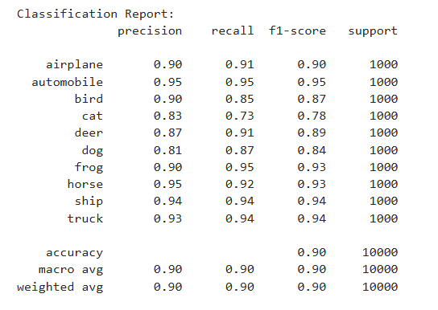The classification report shows detailed performance metrics for each class. Overall accuracy reached 90%, with macro and weighted averages of 0.90 for precision, recall, and F1-score. Performance varies by class:
- Best performing classes: automobile (0.95 F1-score), frog (0.93), horse (0.93), ship (0.94), and truck (0.94)
- Moderate performing classes: airplane (0.90), bird (0.87), and deer (0.89)
- Most challenging classes: cat (0.78) and dog (0.84)

Confusion Matrix
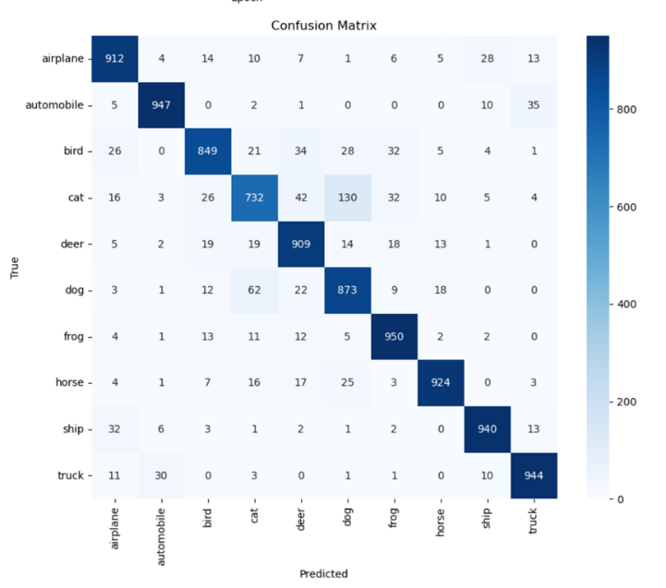
The confusion matrix visualizes prediction patterns across all classes. The dark blue diagonal represents correct predictions, while off-diagonal elements show misclassifications. Key observations include:
- Highest accuracy: frog (950/1000), automobile (947/1000), and truck (944/1000)
- Most challenging: cat (732/1000) and dog (873/1000)
- Notable confusion patterns:
  - Cat-dog confusion (130 cats classified as dogs)
  - Bird misclassifications spread across multiple animal classes
  - Some confusion between visually similar transportation classes (airplane-ship, automobile-truck)
These results validate the effectiveness of our dual-stream CNN architecture, demonstrating both superior accuracy and significant computational efficiency compared to traditional machine learning approaches.

Conclusion and Future Outlook
The dual-stream CNN architecture proposed in this research has achieved excellent performance on the CIFAR-10 classification task, comprehensively solving the problems of low accuracy and long training times faced by traditional methods in Report 2. Our model not only outperforms traditional methods in performance metrics but also demonstrates significant advantages in training efficiency, interpretability, and resource efficiency.
Although CNNs require more computational resources and a more complex parameter tuning process compared to traditional methods, the substantial performance improvements and superior feature representation capabilities fully justify these additional investments. Future research could explore more flexible inter-stream interaction mechanisms, apply the architecture to more complex visual tasks, and develop lighter and more efficient model variants, further expanding the application scope and performance of this design.
In conclusion, our research not only provides an efficient method for solving the CIFAR-10 classification task but also offers valuable reference and foundation for the application of color channel separation-based deep learning architectures in the field of computer vision.

Applications and Future Development
Our dual-stream CNN architecture has application potential in various practical scenarios, including industrial visual quality control, medical image analysis, environmental monitoring, retail product classification, and content moderation systems. Future performance improvements can be achieved through introducing residual connections, exploring more diverse color space decompositions, implementing more advanced regularization and data augmentation techniques, optimizing training strategies, and applying model lightweight techniques.
Transfer learning is also a highly promising direction, where models pre-trained on large datasets could provide better initial weights for our dual-stream architecture. These potential improvement directions reflect the richer development space and greater potential of CNNs compared to traditional methods.

